Cartel no C.E.I.P. Santa Baia
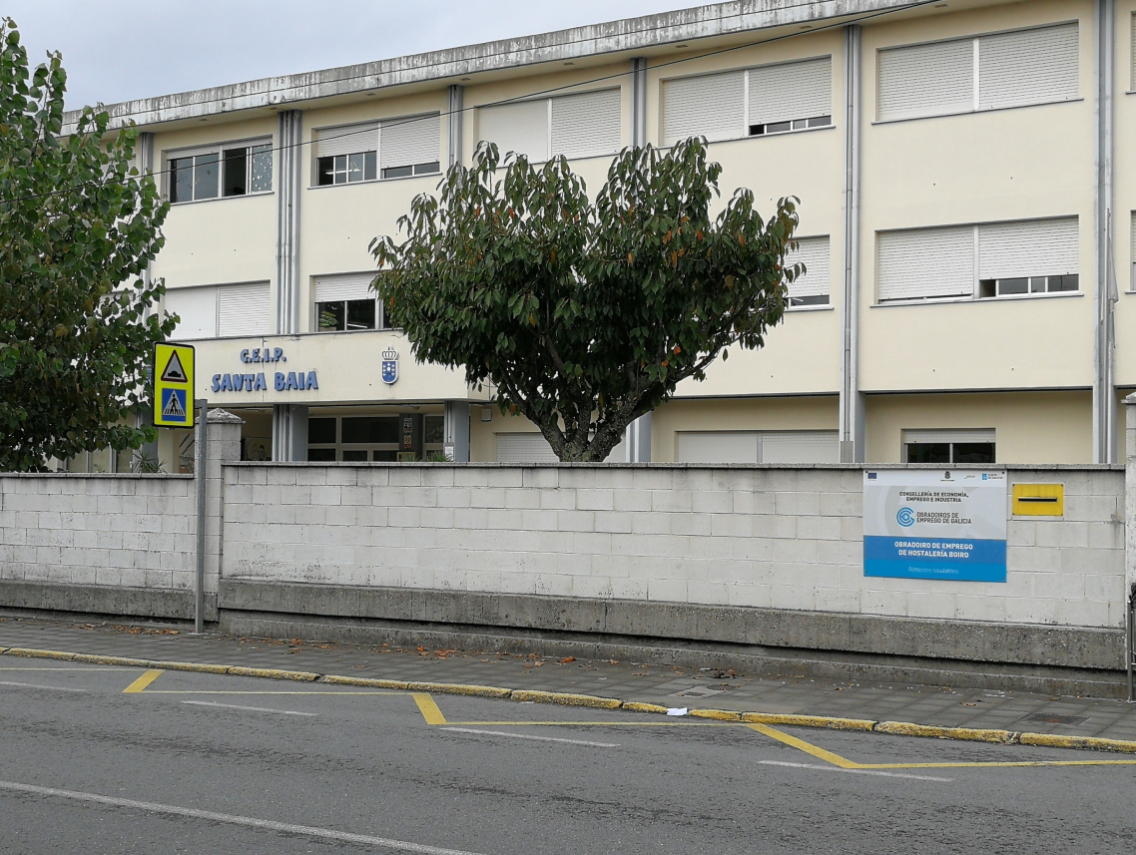

Cartel no C.E.I.P. Praia Xardín
